WHAT CONSTITUTES VOTER FRAUD
and what are the penalties

659:34 Wrongful Voting; Penalties for Voter Fraud.
I. A person is subject to a civil penalty not to exceed $5,000 if such person:
(a) When registering to vote; when obtaining an official ballot; when casting a vote by official ballot; or when applying for a photo identification card for voting purposes, purposely or knowingly makes a false material statement regarding his or her qualifications as a voter to an election officer or submits a voter registration form, an election day registration affidavit, a qualified voter affidavit, a challenged voter affidavit, an affidavit of religious exemption, an identification card voucher, or an absentee registration affidavit containing false material information regarding his or her qualifications as a voter;
(b) Votes more than once for any office or measure;
(c) Applies for a ballot in a name other than his or her own;
(d) Applies for a ballot in his or her own name after he or she has voted once;
(e) Votes for any office or measure at an election if such person is not qualified to vote as provided in RSA 654;
(f) Gives a false name or answer if under examination as to his or her qualifications as a voter before the supervisors of the checklist or moderator;
(g) Presents falsified proof of identity, domicile, or verifiable action of domicile at any election;
(h) (not enforced by court order)
(i) Purposely and knowingly provides false information in a written and signed statement or other documentation that another person is domiciled at an address that is owned, leased, rented, or managed by the individual providing the statement for the purposes of voter registration and that statement is used for voter registration purposes.
II. A person is guilty of a class B felony if, at any election, such person purposely or knowingly commits an act specified in subparagraph I(b) or I(e). A person is guilty of a class A misdemeanor if, at any election, such person purposely or knowingly commits any of the other acts listed in paragraph I, and, if the act involved the use of false proof of identity or voting using the name of another person, the person shall be sentenced to a mandatory sentence in the county correctional facility of not less than 30 days for a first offense under this section, 90 days for a second offense under this section, and 180 days for a third or subsequent offense under this section.
III. The attorney general is authorized to impose a civil penalty under paragraph I. (a) The attorney general may impose a civil penalty by providing written notice to the person: (1) Setting forth the date, facts, and nature of each act or omission which makes the person liable to pay a civil penalty; (2) Specifically identifying the particular provision or provisions of the law involved in each violation; and (3) Advising the person of each penalty that the attorney general imposes and its amount. (b) The written notice shall be served in hand or sent by registered or certified mail to the last known address of such person. The person shall have 30 days to pay any civil penalty assessed under this section to the secretary of state for deposit into the general fund.
IV. The decision of the attorney general to impose a civil penalty may be appealed to superior court. An appeal must be filed within 30 days of the date on which the person received it.
V. The attorney general is authorized to institute a civil action to collect a penalty imposed pursuant to this section. The attorney general shall have the exclusive power to compromise, mitigate, or remit such civil penalties.

659:34-a Voting in More Than One State Prohibited. I. A person is guilty of a class B felony if, at any election, such person knowingly checks in at the checklist and casts a New Hampshire ballot on which one or more federal or statewide offices or statewide questions are listed if the person also casts a ballot in the same election year in any election held in any other state or territory of the United States where one or more federal or statewide offices or statewide questions are listed. For federal or statewide offices and statewide questions, neither the candidates nor the questions need be the same in both jurisdictions for a violation to occur. The titles for offices need not be identical, but must serve an equivalent role in government, for a violation to occur.
II. Two or more elections occur with the same election year if: (a) The election for federal or statewide office or on a question being voted on statewide in another state or territory is held on the same day that New Hampshire holds its general election; or (b) The term of office for any office listed on the ballot in the other state or territory starts in the same year as the term of office for that office or its equivalent in New Hampshire.
III. The state shall not be required to prove that the person actually marked the ballot for a candidate for any specific office; it shall be sufficient to prove that the person cast a ballot. Evidence that a person was checked off on the checklist, or the equivalent record in another state or territory, as having voted is prima facie evidence that the person cast a ballot in that election.
IV. If the election in New Hampshire and the other state or territory are held on different dates, it is an affirmative defense that the person legitimately moved his or her domicile to or from the other state or territory between the dates when the elections were held.

659:35 Showing or Specially Marking Ballot. I. No voter shall allow his or her ballot to be seen by any person with the intention of letting it be known how he or she is about to vote or how he or she has voted except as provided in RSA 659:20.. (not enforced by court order)
II. No voter shall place a distinguishing mark upon his or her ballot nor write in any name as the candidate of his or her choice with the intention of thereby placing a distinguishing mark upon the ballot.
III. No voter shall use or attempt to use any ballot not given him or her by the ballot clerk to accomplish any of the acts or purposes prohibited by paragraph I or II or both.
IV. Any person willfully violating any of the provisions of this section shall be guilty of a violation.
V. Before each state election, the secretary of state shall prepare and distribute to the town and ward clerks a sufficient number of posters measuring 8- 1/2 inches by 11 inches highlighting the provisions of paragraphs I through IV.
VI. Each town and ward clerk shall prominently post the posters referred to in paragraph V at each polling place in his or her town or ward.

659:37 Interfering With Voter, Etc. No person shall interfere or attempt to interfere with any voter when such voter is in the space within the guardrail or endeavor to induce any voter before voting to show how he marks or has marked his ballot. Whoever knowingly violates this section shall be guilty of a misdemeanor if a natural person or guilty of a felony if any other person.

659:38 Forgery; Removing Ballot. No person shall forge or falsely make the official endorsement on any official ballot, or furnish to any voter a ballot with the intent that such voter shall use the same in voting instead of the ballot given him by the ballot clerk, or take or remove any ballot outside the guardrail before the close of the polls, or knowingly delay the delivery of any ballots. Whoever knowingly violates this provision shall be guilty of a misdemeanor if a natural person or guilty of a felony if any other person.

659:40 Bribing; Intimidation; Suppression. I. No person shall directly or indirectly bribe any person not to register to vote or any voter not to vote or to vote for or against any question submitted to voters or to vote for or against any ticket or candidate for office at any election.
II. No person shall use or threaten force, violence, or any tactic of coercion or intimidation to knowingly induce or compel any other person to vote or refrain from voting, vote or refrain from voting for any particular candidate or ballot measure, or refrain from registering to vote.
III. No person shall engage in voter suppression by knowingly attempting to prevent or deter another person from voting or registering to vote based on fraudulent, deceptive, misleading, or spurious grounds or information. Prohibited acts of voter suppression include: (a) Challenging another person's right to register to vote or to vote based on information that he or she knows to be false or misleading. (b) Attempting to induce another person to refrain from registering to vote or from voting by providing that person with information that he or she knows to be false or misleading. (c) Attempting to induce another person to refrain from registering to vote or from voting at the proper place or time by providing information that he or she knows to be false or misleading about the date, time, place, or manner of the election.
IV. Whoever violates the provisions of this section or whoever conspires to violate the provisions of this section shall be guilty of a class B felony.
V. This section is not intended to preclude prosecution or sentencing under any section of RSA 640.

659:40-a Interference With Communications. Any person who, on the day of any election, knowingly blocks, or solicits another person to block, the access of any candidate or committee to the candidate's or the committee's communications equipment or services with the intent of interfering with campaign activity shall be guilty of a class B felony.

659:41 Assault, Etc. Any person who shall assault a town, city, or ward officer as provided in RSA 631 in the discharge of any duty of his office at any election shall be guilty of a class A felony or a class B felony, but never less than a class B felony, other provisions of the law to the contrary notwithstanding. Any person who shall take away, injure or destroy the ballot box or checklist when in use at any election shall be guilty of a class B felony.

659:42 Tampering With Electronic Ballot Counting Devices. Whoever shall tamper with or injure or attempt to injure any electronic ballot counting device for the counting of ballots to be used or being used in an election or whoever shall prevent or attempt to prevent the correct operation of such device or whoever shall tamper with software used in the counting of ballots or design such software so as to cause incorrect tabulation of the ballots or any unauthorized person who shall make or have in his or her possession a key to an electronic ballot counting device to be used or being used in an election shall be guilty of a class B felony if a natural person or guilty of a felony if any other person.

659:43 Electioneering at the Polling Place. I. Electioneering shall be prohibited within the polling place building, provided that nothing in this section shall apply to the posting of sample ballots by election officials, pursuant to RSA 658:26, which have not been marked as voting for any candidate or measure.
II. The moderator shall establish one or more no-electioneering corridors, no less than 10 feet wide, that extend from all entrances of the polling place a reasonable distance along the sidewalks or to the parking lots that serve the polling place. The moderator shall establish the corridor in a manner that permits a voter arriving or leaving the polling place to enter or exit without interruption or interference from individual’s outside the corridor, and that permits a voter to step to the edge of the corridor and speak with those electioneering if he or she chooses.
III. The moderator shall designate a preferred area for electioneering, which to the extent practicable shall be within sight and conversation-level sound of the primary entrance to the polling place and shall abide by any regulations or ordinances approved by the municipality’s governing body pursuant to RSA 31:41-c or RSA 47:17, XIV-a.
IV. Electioneering may occur outside the no-electioneering corridor and outside the designated preferred electioneering area.
V. Electioneering signs shall not be affixed to the polling place building or grounds.
VI. Electioneering signs shall not be left unattended.
VII. The distribution or posting of electioneering communications, including but not limited to posters, cards, handbills, placards, pictures, pins, stickers, circulars, or article of clothing is prohibited within any no-electioneering corridor established outside the polling place by the moderator.

“Who Enforces The Election Law?”

666:8 Attorney General. The attorney general shall be responsible for the enforcement of the election laws as provided in RSA 7:6-c.

Intimidation and Coercion is Unlawful
People must not intimidate, threaten or coerce any other person for registering or voting, or for urging or aiding people in registering or voting. People may not use threats or coercion to interfere with or influence how a person chooses to vote or not vote, or for purposes of preventing a person from voting. 52 U.S.C. §10101, 52 U.S.C. §10301, 18 U.S.C. 241, 242, 245(b), 594.

Election officials must allow a person to vote who is entitled to vote and shall not refuse to tabulate, count and report such person’s vote. 52 U.S.C. §10301, 18 U.S.C. 241, 242, 608 (a).

Election officials shall not deny the right to vote to citizens 18 years of age and older on account of age. 52 U.S.C. §10701

Election officials must retain and preserve, for 22 months after any election that includes a federal candidate all records and papers relating to registration and voting in that election. 52 U.S.C. §20701

Prohibited Acts of Fraud and Misrepresentation by Voters
People shall not make any false statement or claim that they are citizens of the United States in order to register or vote in any Federal, State, or local election. 52 U.S.C. §21144 18 U.S.C. 611, 911, 1015(f).

People shall not vote more than once in any election that includes a federal candidate. 52 U.S.C. §10307

People shall not procure or submit materially false, fraudulent, or fictitious voter registration applications in any election that includes a federal candidate. 42 U.S.C. 1973gg-10(2)(A).

People shall not submit false information as to name, address or period of residence in a voting district for the purpose of establishing eligibility to register or vote in any election that includes a federal candidate. 52 U.S.C. §10307, 52 U.S.C. §21144, 18 U.S.C. 608(b).

People shall not procure, cast, or tabulate materially false, fraudulent or fictitious ballots in any election that includes a federal candidate. 42 U.S.C. 1973gg-10(2)(B)

Can I offer a reward or incentive to people to encourage voting? NO!
People shall not pay, offer to pay or accept payment for voting, registering to vote, withholding their vote, or voting for or against any candidate in any election that includes a federal candidate. 52 U.S.C. §10307, 18 U.S.C. 597, 608(b). RSA 659:39, 40

Reporting Violations
If you have witnessed efforts to commit any kind of fraud or corruption in the voting process, you may report this to:

The Moderator at your polling place
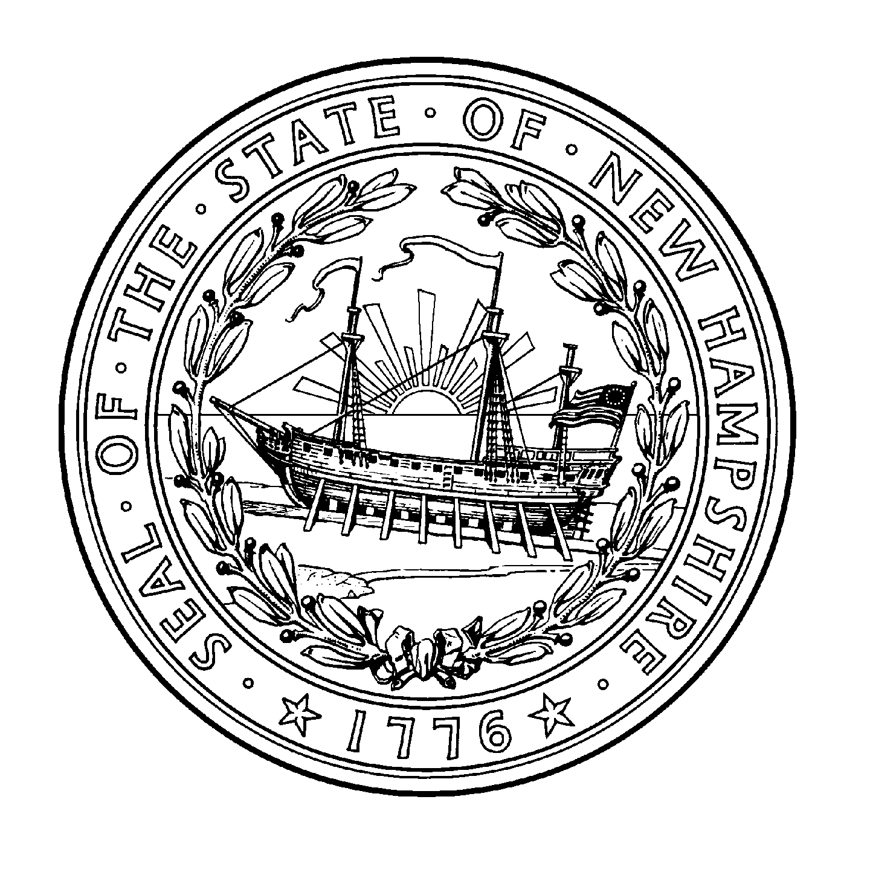
The N.H. Attorney General’s Office toll free at 1-866-868-3703 (866-VOTER03) or
electionlaw@doj.nh.gov

The Secretary of State’s Office at (603) 271-3242 or elections@sos.nh.gov
Website: www.sos.nh.gov

For federal offenses you may also notify:
The U.S. Attorney for New Hampshire at (603) 225-1552

If you have witnessed actual or attempted acts of discrimination or intimidation in the voting process, you may report to the Civil Rights Division of the U.S. Department of Justice at 202-514-4609

#4-2022

