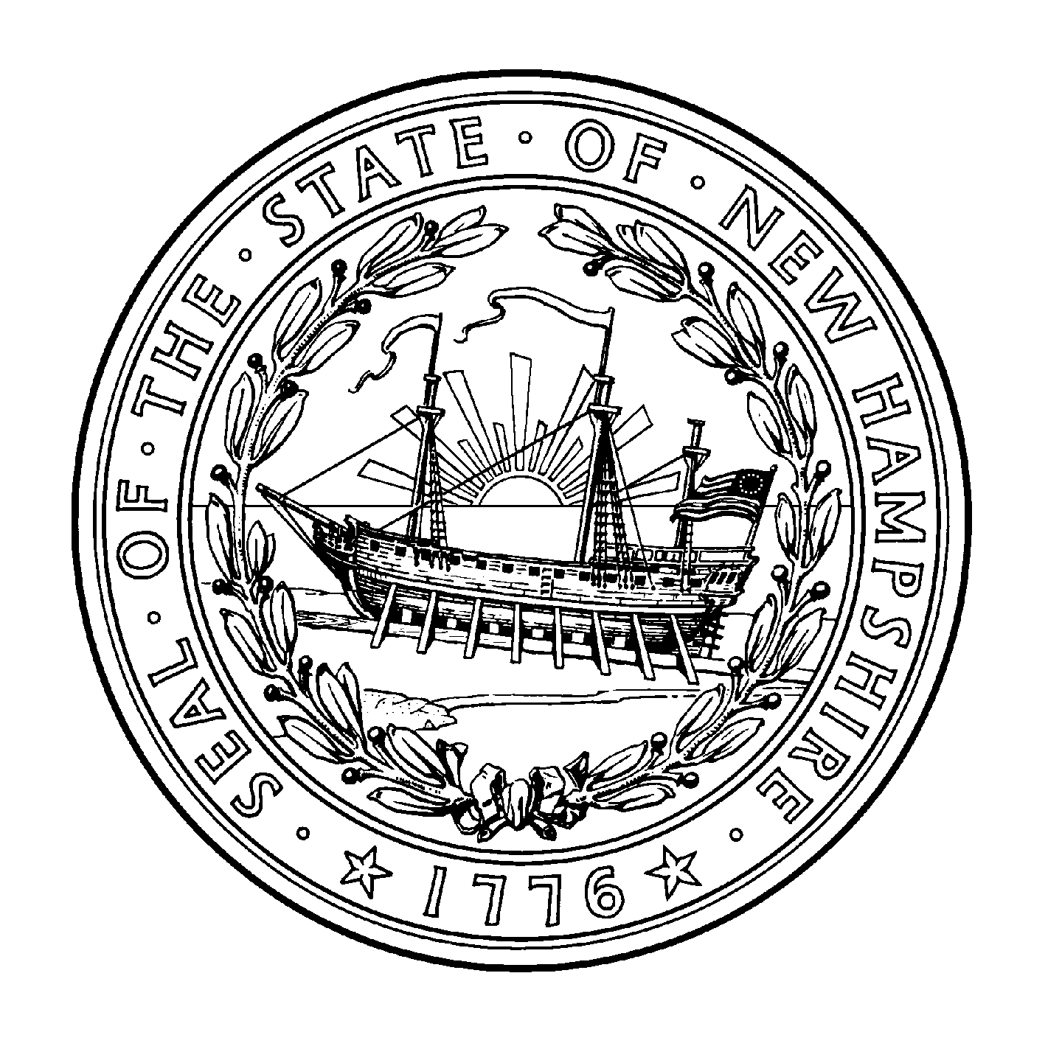New Hampshire Voter ID Law

659:13 Obtaining a Ballot. – I. (a) A person desiring to vote shall, before being admitted to the enclosed space within the guardrail, announce his or her name and address to one of the ballot clerks who shall, if the name is found on the checklist by the ballot clerk, repeat the name and address. If the address announced by voter is different from what appears on the checklist, but is in the same town or ward, the ballot clerk shall record the change of address in red on the paper checklist and the supervisors of the checklist shall cause the centralized voter registration database to reflect the change.
(b) The voter, unless challenged as provided for in RSA 659:27 through 659:33, shall then be asked to present proof of his or her identity meeting the requirements of paragraph II. If the voter presents such proof of identity to the ballot clerk, the ballot clerk shall give the voter one of each ballot to be voted on in that election which shall be folded as it was upon receipt from the secretary of state. The ballot clerk shall also mark the checklist using a ruler or other straight edge to ensure accuracy of the mark in order to show that the voter obtained his or her ballot. If the photo identification is an out-of state driver's license or nondriver's identification card, the ballot clerk shall record the state of issuance on the checklist in accordance with uniform procedures developed by the secretary of state in a color designated for such entries and the supervisors of the checklist or designee shall record the state of issuance of the voter’s driver’s license or identification card in the statewide centralized voter registration database within 30 days of the election. The voter shall then be allowed to enter the space enclosed by the guardrail to mark and cast his or her ballot.
(c)(1) If the voter does not have a valid photo identification, the ballot clerk shall inform the voter that he or she may execute a challenged voter affidavit. The voter shall receive an explanatory document prepared by the secretary of state explaining the proof of identity requirements. If the voter executes a challenged voter affidavit, the ballot clerk shall mark the checklist in accordance with uniform procedures developed by the secretary of state.
(2) If the voter executes a challenged voter affidavit, the moderator or the moderator's designee shall take a photograph of the voter and immediately print and attach the photograph to, and thus make it a part of, the affidavit form. However, if a photograph was taken under RSA 654:12, then a notation shall be made on the challenged voter affidavit stating that the photograph is attached to the qualified voter affidavit or sworn statement on the general election day registration form. The photograph shall be 2 inches by 2 inches, or larger, and may be in color or in black and white. The moderator or his or her designee who took the photograph and the voter shall then sign the challenged voter affidavit. The moderator or designee shall delete the photograph from the camera in the presence of the voter. If the moderator or his or her designee is unable to take the voter's photograph due to equipment failure or other cause beyond the moderator's or his or her designee's reasonable control, the voter may execute a challenged voter affidavit without a photograph.
(3) If the voter objects to the photograph requirement because of religious beliefs, he or she may execute an affidavit of religious exemption in accordance with RSA 659:13-b, which shall be attested to by an election officer and attached to the challenged voter affidavit.
(4) The person entering voter information into the centralized voter registration database shall cause the records to indicate when a voter has not presented a valid photo identification and has executed a challenged voter affidavit.
II. (a) A valid photo identification shall show the name of the individual to whom the identification was issued, and the name shall substantially conform to the name in the individual's voter registration record; it also shall show a photograph of the individual to whom the identification was issued. The photo identification shall also have an expiration date that has not been exceeded by a period of more than 5 years , except that a voter 65 years of age or older may use an otherwise qualified form of identification without regard to expiration date, and except that student identification cards shall comply with the date requirements in subparagraph (5). The following forms of identification bearing a photograph of the voter shall satisfy the identification requirements of paragraph I:
(1) A driver's license issued by any state or the federal government.
(2) An identification card issued under RSA 260:21, RSA 260:21-a, or RSA 260:21-b or a nondriver's identification card issued by the motor vehicles division, department, agency, or office of any other state.
(3) A United States armed services identification card.
(4) A United States passport or passcard.
(5) A valid student identification card if:
(A) The card is issued by:
(i) A college, university, or career school in New Hampshire and approved to operate or licensed to operate in New Hampshire.
(ii) A public high school in New Hampshire.
(iii) A nonpublic high school in New Hampshire accredited by a private school accrediting agency that is recognized by the department of education.
(iv) Dartmouth College.
(v) A college or university operated by the university system of New Hampshire or the community college system of New Hampshire.
(B) The card has either an expiration date or an issuance date that has not been exceeded by a period of more than 5 years, except that, at all elections prior to September 1, 2018, student identification cards without a date of expiration or issuance shall be accepted.
(6) A challenged voter affidavit in accordance with subparagraph I(c).
(7) A photo identification not authorized by subparagraphs (1) through (6) but determined to be legitimate by the supervisors of the checklist, the moderator, or the clerk of a town, ward, or city, provided that if any person authorized to challenge a voter under RSA 659:27 objects to the use of such photo identification, identifies the reason for the objection in writing, and states the specific source of the information or personal knowledge upon which the challenge of the photo identification is based, the voter shall be required to execute a challenged voter affidavit as if no identification was presented.
(b) In addition to the forms of photo identification authorized in subparagraph (a), the identification requirements of paragraph I may be satisfied by verification of the person's identity by a moderator or supervisor of the checklist or the clerk of a town, ward, or city, provided that if any person authorized to challenge a voter under RSA 659:27 objects to such verification, identifies the reason for the objection in writing, and states the specific source of the information or personal knowledge upon which the challenge of the photo identification is based, the voter shall be required to execute a challenged voter affidavit as if no verification was made.
(c) The secretary of state shall post the lists of educational institutions provided by the commissioner of the department of education under RSA 21-N:4, VII on the department of state's website, and otherwise shall make such lists available to local election officials.
III. If a voter on the nonpublic checklist executes an affidavit in accordance with subparagraph I(c), the affidavit shall not be subject to RSA 91-A.
IV. (a) The secretary of state shall cause a letter of identity verification to be mailed by first class mail to each voter who executed a challenged voter affidavit or affidavit of religious exemption in accordance with paragraph I, unless the same person is sent letter of identity verification pursuant to RSA 654:12, V(b). The letter shall be mailed by January 10 in every odd-numbered year in the case of persons executing challenged voter affidavits or affidavits of religious exemption at a state primary or general election, or within 90 days after any other election. The secretary of state shall mark the envelope with instructions to the United States Post Office not to forward the letter and to provide address correction information. The letter shall notify the person that a person who did not present valid photo identification voted using his or her name and address and instruct the person to return the letter within 30 days with a written confirmation that the person voted or to contact the attorney general immediately if he or she did not vote. The letter shall also inform the person of the procedure for obtaining a free nondriver's picture identification card for voting purposes.
(b) The secretary of state shall conduct an inquiry regarding any letters mailed pursuant to subparagraph (a) that are returned as undeliverable by the United States Post Office and of voters who were mailed letters under subparagraph (a) and have not responded to the secretary of state. The inquiry may include consulting with, and examining public records held by, municipal officials, which contain information relevant to a person’s qualifications to vote in New Hampshire, and interviewing persons living at the address listed on the letters. After such inquiry, the secretary of state shall prepare and forward to the attorney general for investigation a list of those people whose identity or eligibility to vote could not be confirmed. The attorney general shall cause an investigation to be made to determine whether fraudulent voting occurred.
(c) Within 60 days after any election held after November 1, 2012, the secretary of state shall compile a report by voting district of the number of voters who registered or voted on election day but did not present valid photo identification, and forward the report to the speaker of the house of representatives, the president of the senate, and the chairpersons of the appropriate house and senate standing committees with jurisdiction over election law.
V. (a) The secretary of state shall provide to each town or city the photography equipment, supplies, and printing device that are necessary to enable it to comply with the photograph provision of subparagraph I(c), along with instructions in their use.
(b) If the moderator or his or her designee is unable to take the voter's photograph due to equipment failure or other cause beyond the moderator's or his or her designee's reasonable control, the secretary of state may waive a voter's compliance with the photograph requirement of subparagraph I(c).

September 2022

