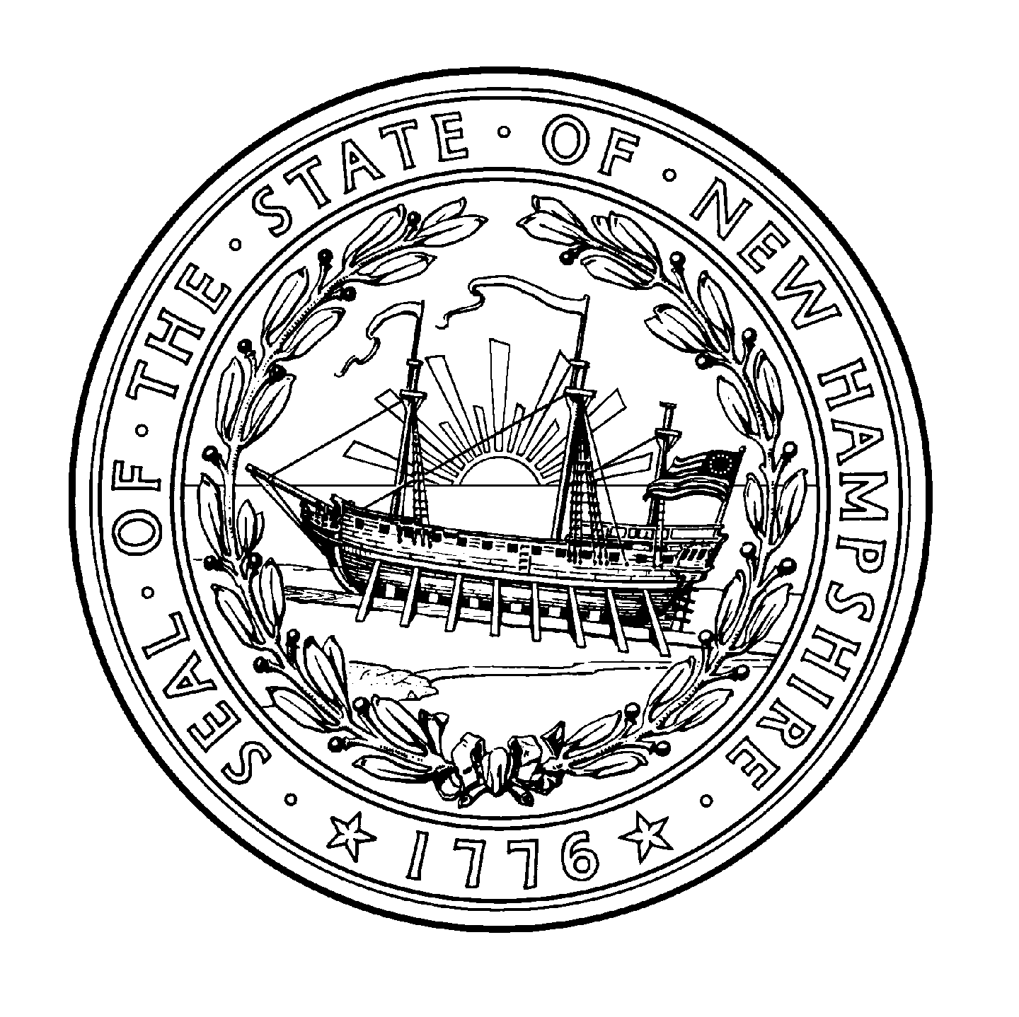

Electronic/Remote Notarization
Notification Form

Name - Notary / Justice of the Peace _______________________________ _________________________________
(Print Name as Commissioned)
Commission Expiration date

County of Commission

Current Business Address, City, State, Zip Code

Current Business Email Address ________________________________

Current Business Phone Number

I am a (circle or underline all that apply) Notary Public / Justice of the Peace for the State of New Hampshire. I will be performing notarial acts with electronic documents and/or facilitated by communication technology.

I will be using electronic notarization and/or technology for notarial acts facilitated by communication technology provided by

________________________________________
(insert name(s) of vendor(s) - Remote Online Notarization Provider).

I certify that I will be using an X.509 industry digital certificate (or the industry equivalent) provided by

____________________________________________________________________________________
(insert name of digital certificate provider)

My signature below acknowledges my understanding that:
- I must abide by all of the laws and regulations concerning notarial acts in the State of New Hampshire
- I must notify the Office of the Secretary of State if I change or add technology vendors.
- I may NOT charge more than $25 for each electronic or remote notarial act using audio-visual communication technology.

__
(Signature of Notary Public or Justice of the Peace)
All information provided on this form will be public
This completed form may be submitted by email to elections@sos.nh.gov, or US mail to the Department of State, State House Room 204, 107 North Main Street, Concord, NH 03301-4989.

User Notification Form 2.22

